**COS60009 – Database Management System for the Big Data age**

**Group Assignment -2**

**Group Members:**

Arun Ragavendhar Arunachalam Palaniyappan 104837257

Christopher Opie 105380202

Yung Lien Wu 105214039

Nichakorn Srisupornwong 104835031

**Task 1: XML and DTD**

The required DTD and XML has been generated and has been shared as an .dtd file and .xml file respectively, attached along.

The xml Validation was successful with the defined DTD

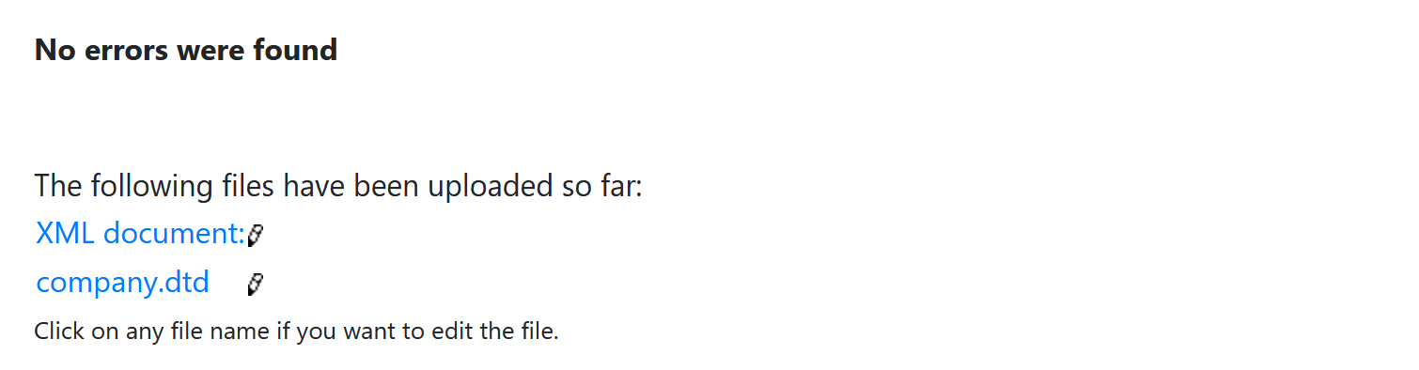

**Task 2: XPath and JSON**

**3.1 For the XML document classes.xml shown below, write the XPath expressions for the following queries.**

1. **Find the instructor of all classes.**

distinct-values(/classes/class/instructors/instructor)

1. **Find the title for those classes with “Grant” as an instructor.**

/classes/class[instructors/instructor = 'Grant']/title

1. **Find the classID attribute for those classes with “yes” in attribute *req* of credits.**

/classes/class[credits/@req = 'yes']/@classID

1. **Find titles for those classes with more than one instructor.**

/classes/class[count(instructors/instructor) > 1]/title

**3.2 Convert the XML document classes.xml to its JSON format.**

**The JSON equivalent for the XML given**

 {

    "classes":

        [

          {

            "classID": "CS115",

            "department": "ComputerScience",

            "instructors": ["Adams", "Dykes"],

            "title": "Programming Concepts",

            "credits": {

              "req": "yes",

              "value": 3

            }

          },

          {

            "classID": "CS205",

            "semester": "fall",

            "department": "ComputerScience",

            "instructors": ["Grant"],

            "title": "JavaScript",

            "credits": {

              "req": "yes",

              "value": 3

            }

          },

          {

            "classID": "CS255",

            "semester": "fall",

            "department": "ComputerScience",

            "instructors":["Adams", "Grant", "Dykes"],

            "title": "Java",

            "credits": {

              "req": "no",

              "value": 3

            }

          }

        ]

  }

The JSON has also been validated using an Online JSON validator.

